SEO Audit

Customer Name: | Absoltz- Internet Marketing | Website: | http://www.absoltz.com/#gref
Auditor Name: | Meenu Makan | Completion Date: | 21-12-2018

Performing Well | Needs Improvement | Critical Fix

Website Traffic: | 7 | Referring Domains: | 131
Backlinks: | 7.0k | Top Keywords: | Dedicated SEO services
Pages Audited: | Homepage

Recommendation

The recommendations in this document should be fixed in the order they are listed, first by section and then by color with red being the most immediate fix.
- Absoltz’s organic traffic is 7 while on comparing with one of your competitors (WME Group) their organic traffic is 12.2k. Need to strategize for increasing website traffic.
- Absoltz has 7.0 K backlinks as compared to one of your competitors (WME Group) they have 55.8k. Need to work on backlink strategy for better results and rankings.
- There are 109 pages with duplicate meta titles which needs to be fixed.
- Duplicate and empty meta descriptions needs to be investigated and fixed.

Additional Findings

- ‘About us’ which is present on the menu bar is redirecting to About Us page but its URL is not correct i.e. URL includes some characters which need to be fixed.
Also, the About Us button which is present above the fold as a CTA is redirecting to the correct URL. So both about us redirecting to the different URLs which needs to be fixed.
- When we click on the About Us which is present on the menu bar, it is displaying the incomplete information. This needs to be fixed.
- In the footer, on its blog section, it is showing “No post found” which needs to be fixed. We can display some of our highly visited blogs on this section which will help visitors to navigate to our blogs easily. Here is the screenshot attached for your reference.
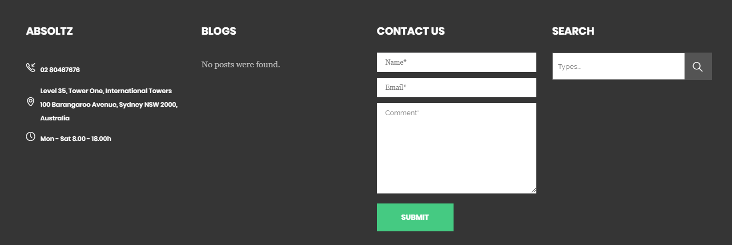

Conversion
Before turning your focus to ranking high in search engines, it is essential to make sure your website is set-up to convert the traffic the website receives. This ensures you get the most out of your SEO efforts. These are the additional techniques your website can apply to increase conversion.

Call To Action | A specific call-to-action (CTA) is present above the fold on your website to drive prospective customers to become leads.
Navigation | The website is well organized & easily navigable by the visitor.

Social Proof | Social proof can greatly increase a website's conversion rate.  Social media profiles i.e., Facebook & LinkedIn are connected to the website providing information to the user about their respective pages but the logo in these social media profiles has not been updated which may not increase the customer’s trust visiting the website.  We can also add social proof to a website like awards or achievements. It increases the customer's trust who are visiting the website.

Favicon | The website does have a professional favicon.

Logo | The website does have a unique and professional logo.

Phone Number | The website does have a clear phone number on the homepage.  Providing a primary phone number on the homepage & website is always the best practice so that the visitor can easily find the information.

Current Rankings | Absoltz is ranking on the keywords which are mentioned below

Keywords in which Absoltz is ranking-
- Internet Marketing Sydney- 6th Position
- Dedicated SEO Services- 6th Position
- Internet Marketing Australia- 22nd position

Following are some keywords which can be used to increase the ranking of your website-

- SEO Company Australia (Average monthly searches- 100- 1k)
- SEO Services Australia (Average monthly searches- 100-1k)
- Online Marketing Agency (Average monthly searches- 100- 1k )
- Internet Marketing Agency (Average monthly searches- 100-1k )

On Page Optimization
With your website better set-up to convert visitors, attention needs to turn to better optimizing the websites you'd like to target. This means each page needs to be set-up for search engines to crawl and index correctly to achieve top rankings.

Keywords | Homepage uses the keywords like – Absoltz internet marketing, online marketing, internet marketing company which are mapped with the content and has keyword density between 1-2% which is good to rank well in search engines.

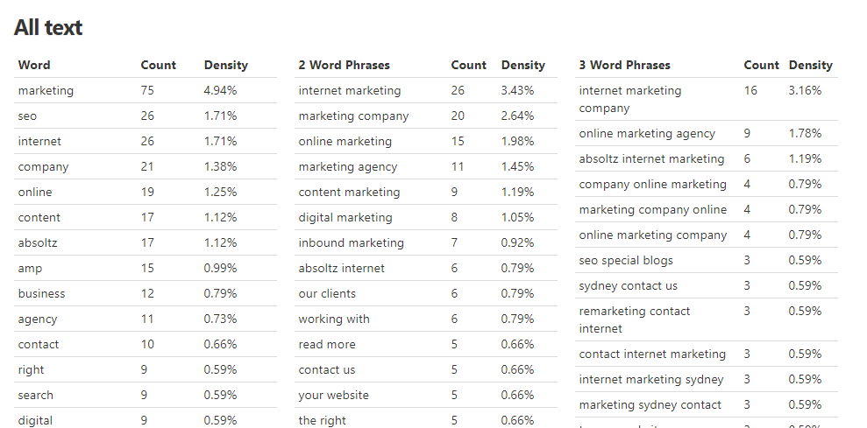

Duplicate Meta Titles | There are 109 pages with duplicate meta titles in reference to the below-attached examples. These web pages need to be fixed.
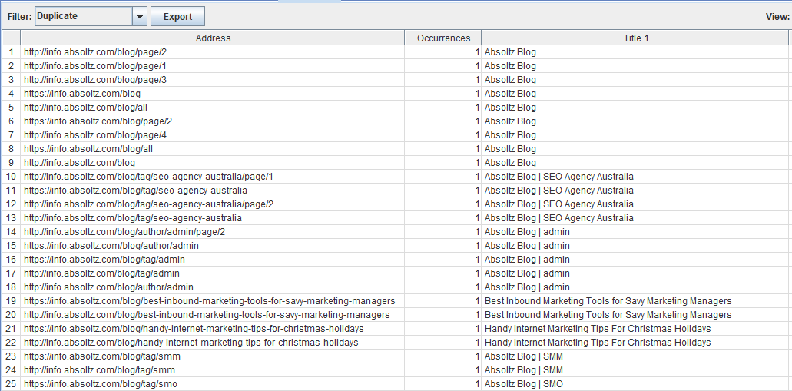
Empty Description | Description of the website must be unique and compelling.  There are total 23 empty meta descriptions which need to be investigated & fixed. Here is a list of some pages with empty meta description for reference-

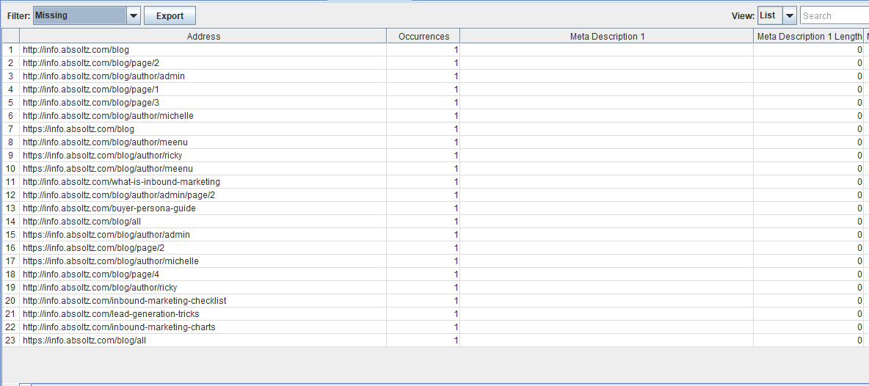

Duplicate Meta Description | There must be unique and fresh description in a website.  There are total 86 pages with duplicate meta description in your website which needs to be fixed.  Here is a list of pages with duplicate meta description for reference-

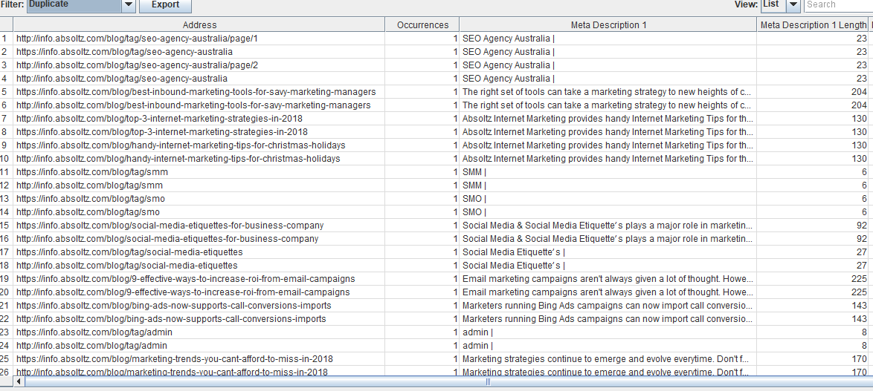

URL Structure | In order for URLs to be SEO friendly, they should be clearly named for what they are and contain no spaces, underscores or other characters. URL structure of “About us page” is not properly designed as it contains some special characters which need to be corrected.  For example-  http://www.absoltz.com/about-us/#About%20Absoltz  It should be like this-  http://www.absoltz.com/about-us/

Text Formatting | Header tags help Google identify what your page is about.  H1 & H2 headers are present on the home page of your website.

Use of Internal Link Structure | Internal Links are present on the website on the Menus, Footer & in between the content.  The website does have links in between the content of each page which is good for the website.

Optimized Images | Compressed images can save many bytes of data ,with the same image quality, which will ensure that page loads much quicker.  Below is a chart and list of images need to be compressed.

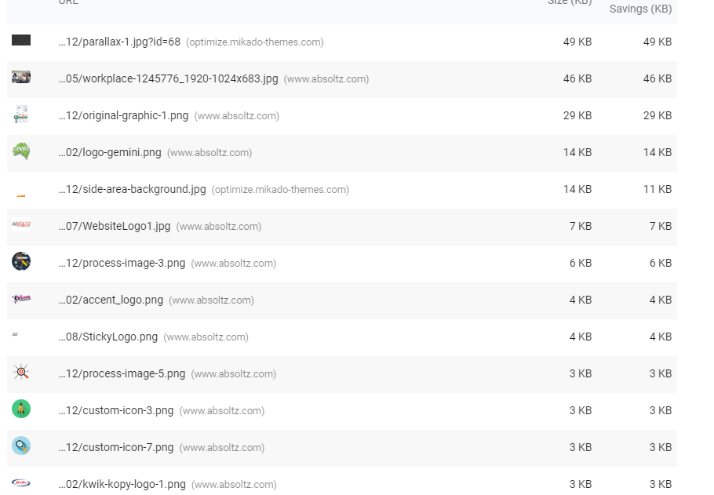

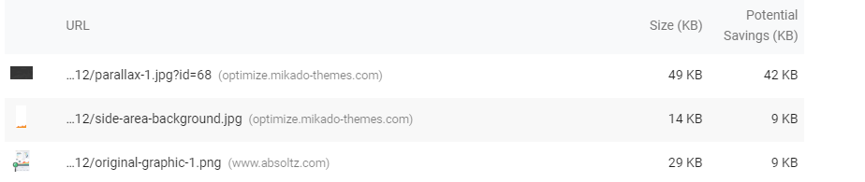

Page Speed | Desktop Page Speed 71/ 100  Possible Optimizations  - Defer unused CSS  - Eliminate render-blocking resources  Mobile Page Speed 26/100  Possible Optimizations  - Eliminate render-blocking resources  - Defer unused CSS  - Defer offscreen images  - Serve images in next-gen formats  - Efficiently encode images

Broken Links | There are no broken links in your Website which is very essential to rank well in search engines and engage visitors to your website as well.

Custom 404 Page | A customized 404 page can help your visitors back to a working page on your website can greatly improve the user’s overall experience.  Yes, the website contains Custom 404 page.

Website Standards & Tools
It is essential to use the tools provided by the search engines so that they can notify you of any errors they find when crawling your website and so you can monitor what's happening with your website in search engines.

Google Analytics | Google analytics is a powerful tool that shows you where people come from.  Google Analytics tag is set up properly on your website.

XML Sitemaps | The sitemap gives priority information to the search engines.  XML Sitemaps is present on your website.

Robots  .txt | Robots.txt file is available on your website.

Off Page Optimization
With your website properly optimized, you're ready to start marketing your website elsewhere on the internet.

# of Incoming Links | According to Search engines, other website will approach your website if it is useful. This is why you should work on building external links to your website and much attention to be paid on the quality of the websites linking to your, not the quantity. As a local business, you can submit your website to quality local business directories, yellow pages, and review sites which is beneficial for your website.  Currently, there are 7.0k backlinks coming to your website whereas, one of your competitors (WME Group) currently has 55.9k total backlinks. Hence, backlink strategies need to be improved.  Here is the screenshot attached for your reference.

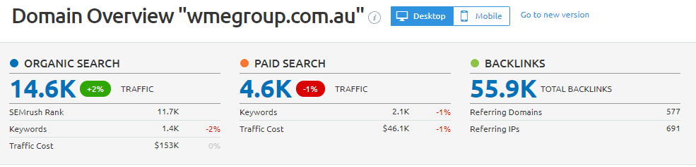

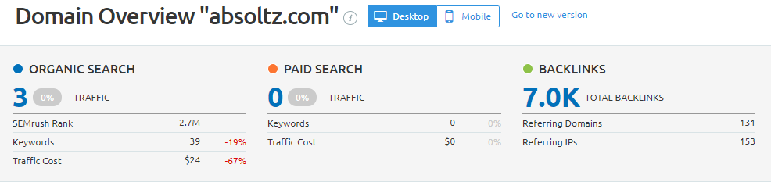

Domain  Authority | Your website's domain authority is 25 (on a scale of 100). Your domain authority tells you how likely your website is to rank highly in search results.  Domain Authority can be improved by incorporating detailed off strategy.

